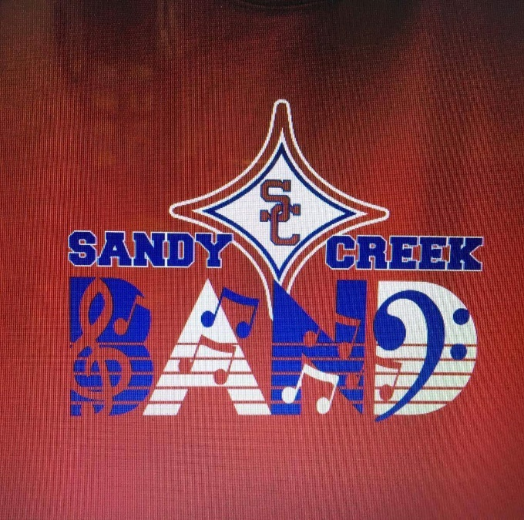
Receipt – 2018 Sweetheart Dinner
Sandy Creek Band Booster Club - Tax ID# 58-2005261

Purchaser
Date Sold By
Ticket Quantity Total Collected

Thank you for your purchase of ticket(s) to our 4th Annual Valentine’s Dinner on Thursday, February 8, 2018 at 7pm at the Tyrone Recreation Center in Tyrone, GA. The proceeds from the sale of each ticket will benefit the Sandy Creek High School Band Program by allowing us to purchase new and repair existing instruments that are sorely needed.
This year, we have added a silent auction to the event so please come prepared to bid on a special item. 100% of the donations made to the silent auction is tax-deductible.
For more information about the Sandy Creek High School Band Program, please visit our website at www.sandycreekband.org.

Thank you for your support! SCHS Band Boosters tax ID# 58-2005261

This Photo by Unknown Author is licensed under CC BY-SA
This Photo by Unknown Author is licensed under CC BY-SA
This Photo by Unknown Author is licensed under CC BY
www.sandycreekband.org https://www.facebook.com/sandycreekhsbands @SandyCreekBand

